Test Summary Report

Team 2
Fall 2025

Table of Contents

1. Purpose (Koushika Chappidi) 3
2. Application Overview (Kevin Rodrigues) 3
3. Testing Scope (Sreenitha Rayapuraju) 3
4. Metrics (Sharvani Kadarla) 4
5. Types of testing performed (Nimisha George) 7
6. Test Environment & Tools (Sreenitha Rayapuraju) 8
7. Lessons Learnt (Sharvani Kadarla) 9
8. Recommendations (Nimisha George) 9
9. Best Practices (Koushika Chappidi) 10
10. Exit Criteria (Kevin Rodrigues) 10
11. Conclusion/Sign Off (Kevin Rodrigues) 10
12. Definitions, Acronyms, and Abbreviations (Sharvani Kadarla) 10

1. Purpose (Koushika Chappidi)

The purpose of this Test Summary Report is to present a consolidated overview of all testing activities performed during the evaluation of the Invoicing, Account Receivable and Accounting Reports module in the Xero cloud-based accounting system.

This report summarizes the testing objectives, scope, methodologies, metrics, key findings, and overall effectiveness of the test cycles executed. It provides a clear assessment of whether the system’s functionality aligns with the defined business requirements and ensures that all critical workflows operate as expected.
Additionally, this document serves as formal evidence of test completion and supports decision-making regarding system readiness for deployment.

2. Application Overview (Kevin Rodrigues)

Xero is a cloud-based accounting application designed for businesses to manage their financial operations efficiently and securely. The platform provides a comprehensive suite of financial tools that enable users to automate bookkeeping tasks, maintain accurate records, and streamline business workflows.

The application offers key functionalities such as bank reconciliation, invoicing, quotes, bill management, inventory tracking, payroll, reporting, and integration with third-party payment services. Automated bank feeds, rule-based reconciliation, and intuitive dashboards help users stay up-to-date with cash flow and business performance.

Xero also incorporates robust role-based access controls, allowing organizations to customize permissions for different user roles. Its modular design ensures that updates made in one area—such as invoices, contacts, or payment services—are automatically reflected across the system.

Overall, Xero provides a reliable, user-friendly accounting environment focused on automation, accuracy, and efficiency, supporting businesses in managing end-to-end financial processes with minimal manual effort.

3. Testing Scope (Sreenitha Rayapuraju)

The following activities and functional areas were included within the scope of this testing cycle:
Verification of core business workflows within the Team 2 modules, including invoice processing (Module 06), customer data retrieval (Module 07), and accounting report generation (Module 12).
Role-based access validations, ensuring users with different permission levels can only perform invoicing and reporting actions appropriate to their roles.
Functional testing of user interface behaviors, such as navigation, filtering (date, customer, status), data display, editing invoice details, and exporting reports.
Data Flow validations (DF-In/DF-Out) to confirm that invoices and reports pull the latest data from Accounts Receivable and Payroll sources, and that exported report outputs match on-screen values.
Calculation logic checks, verifying accuracy of invoice totals, taxes, FX conversions (multi-currency), and payroll summary computations.
Cross-cutting concerns, including entitlement checks, status updates (Draft/Approved/Paid), field behaviors, audit trail updates, and automatic recalculations when data changes.

(b) Out of Scope — Overall System Limitations
The following items were intentionally excluded from this phase of testing:
Modules assigned to other teams, including functionality not part of the current testing allocation.
Integration with external systems, such as banking APIs, third-party payroll systems, or external reporting tools, due to lack of access to their environments.
Performance, load, and stress testing, as the scope focused solely on functional accuracy rather than system scalability under high-volume usage.
Security assessments, including penetration testing, authentication hardening, and vulnerability scanning.
Mobile platform testing, as the execution environment was limited to desktop/laptop browsers.

(c) Items Not Tested — General Exclusions
These functionalities were not covered because they extend beyond the core requirements for this cycle:
Advanced analytics and custom reporting capabilities that require data aggregation from modules beyond the assigned coverage.
Historical and multi-year data validation, as the focus was on functional correctness for the current test period.
Automated or scheduled background processes, such as recurring report deliveries or scheduled batch jobs.
Third-party application add-ons, which require separate configurations or paid subscriptions not provided in the test environment.

4. Metrics (Sharvani Kadarla)

The Metrics section provides a detailed, visual summary of the testing progress and product quality across Cycle 1 and Cycle 2. These metrics help evaluate test coverage, defect distribution, requirement validation, and the overall effectiveness of each test cycle. The graphical reports and pie charts highlight key trends that support decision-making for release readiness and future improvement.

CYCLE 1 METRICS:

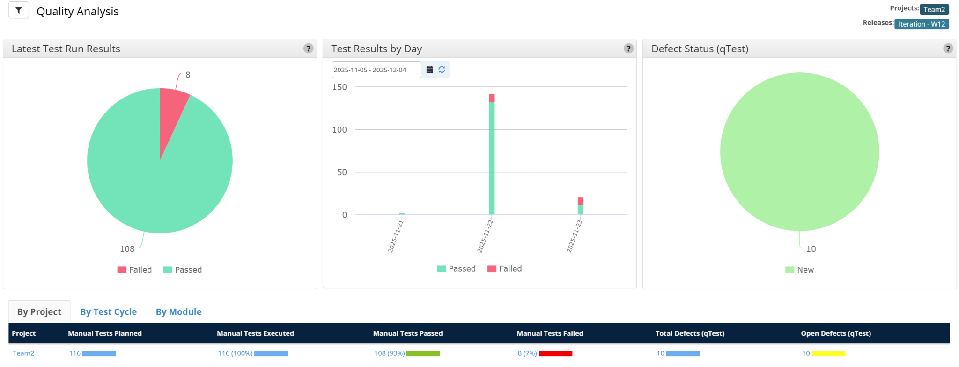

This chart illustrates the overall quality status of the project during Cycle 1. It summarizes the proportion of test cases that passed, failed, were blocked, or remain unexecuted.
- Helps understand the stability of the application at the project level.
- Shows whether quality improved.
- Highlights any major shifts in defect density or test performance.

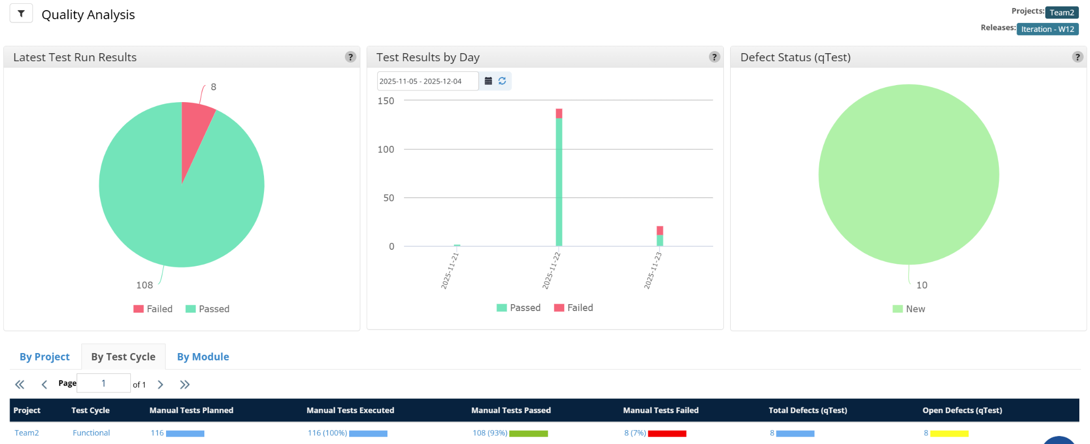

This metric breaks down test execution results for each test cycle individually.
- Shows the effectiveness of each cycle’s execution.
- Useful for analyzing progress and validating whether critical issues were resolved.
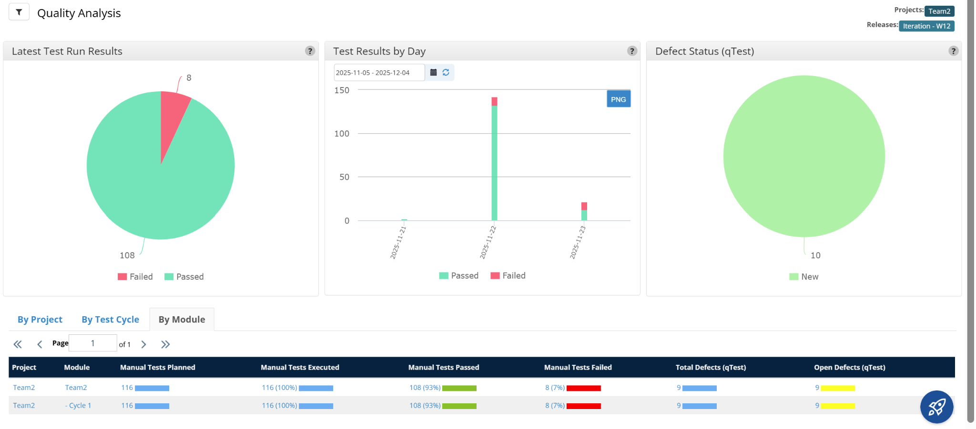

This analysis displays the quality status across different functional modules of the application.
- Identifies modules with higher failure rates or instability.
- Highlights modules that require more testing focus or redesign.
- Helps stakeholders understand which areas are high-risk versus stable.

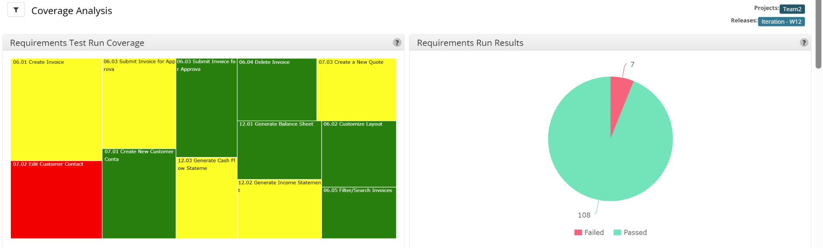

- Shows coverage of each test design document, its test cases, and related test run requirements.
- Ensures all functional requirements are included and tested.
- Indicates completeness of the testing effort and highlights any untested requirements.
- Presents execution results of requirements based on their linked test cases.
- Shows which requirements passed, failed, or were blocked.
- Ensures requirement-level traceability and supports overall quality assurance.

CYCLE 2 METRICS:

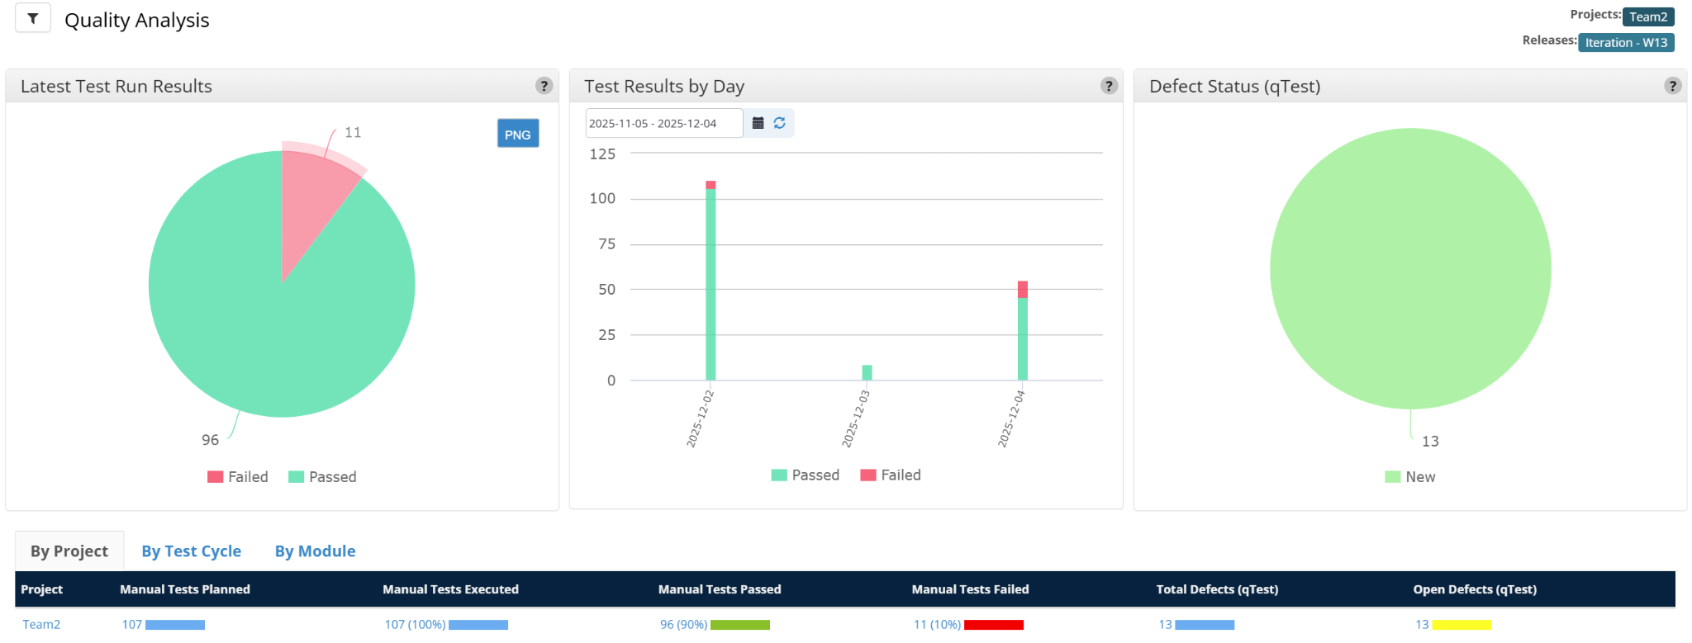

This chart illustrates the overall quality status of the project during Cycle 2. It summarizes the proportion of test cases that passed, failed, were blocked, or remain unexecuted.
- Helps understand the stability of the application at the project level.
- Shows whether quality improved.
- Highlights any major shifts in defect density or test performance.

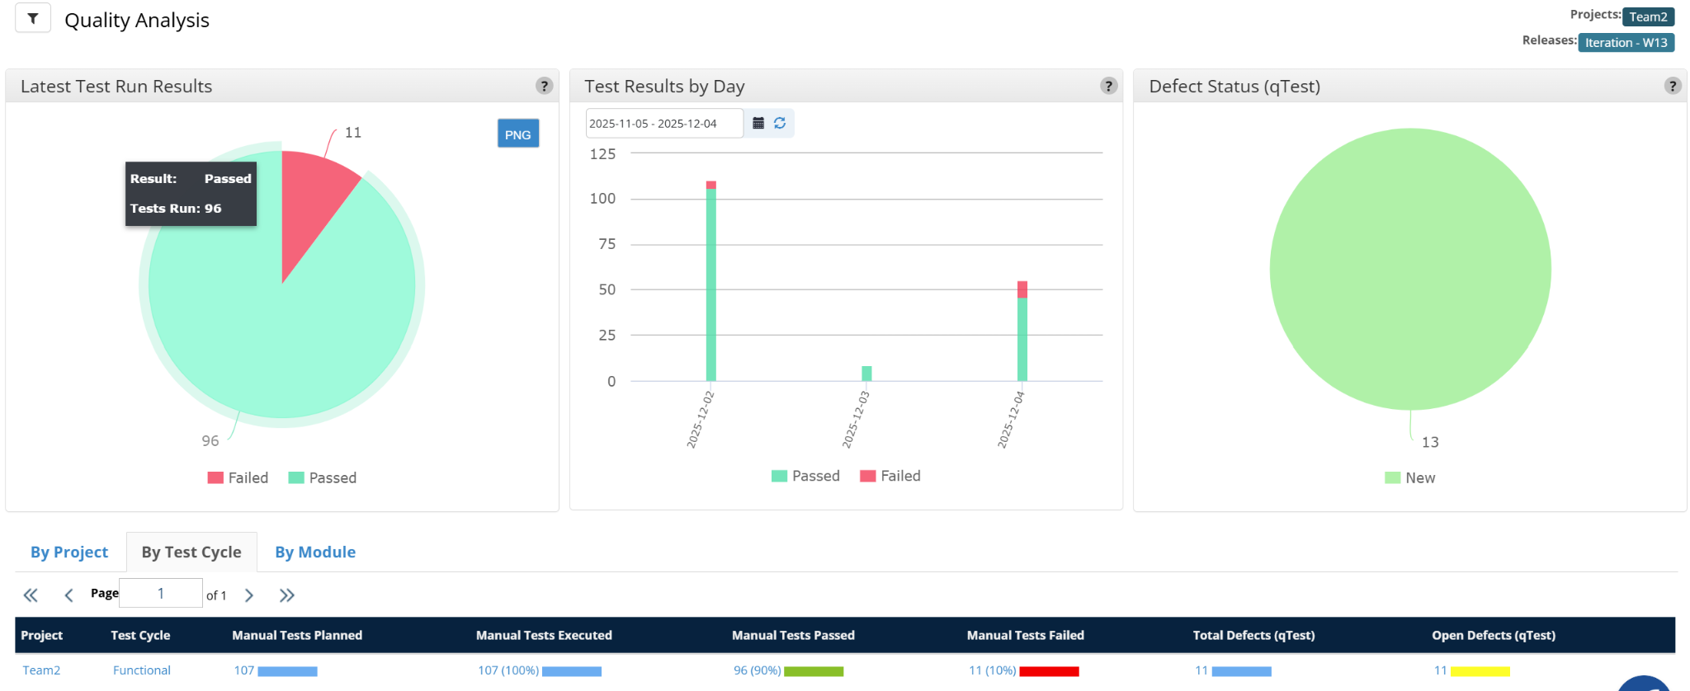
This metric breaks down test execution results for each test cycle individually.
- Shows the effectiveness of each cycle’s execution.
- Useful for analyzing progress and validating whether critical issues were resolved.

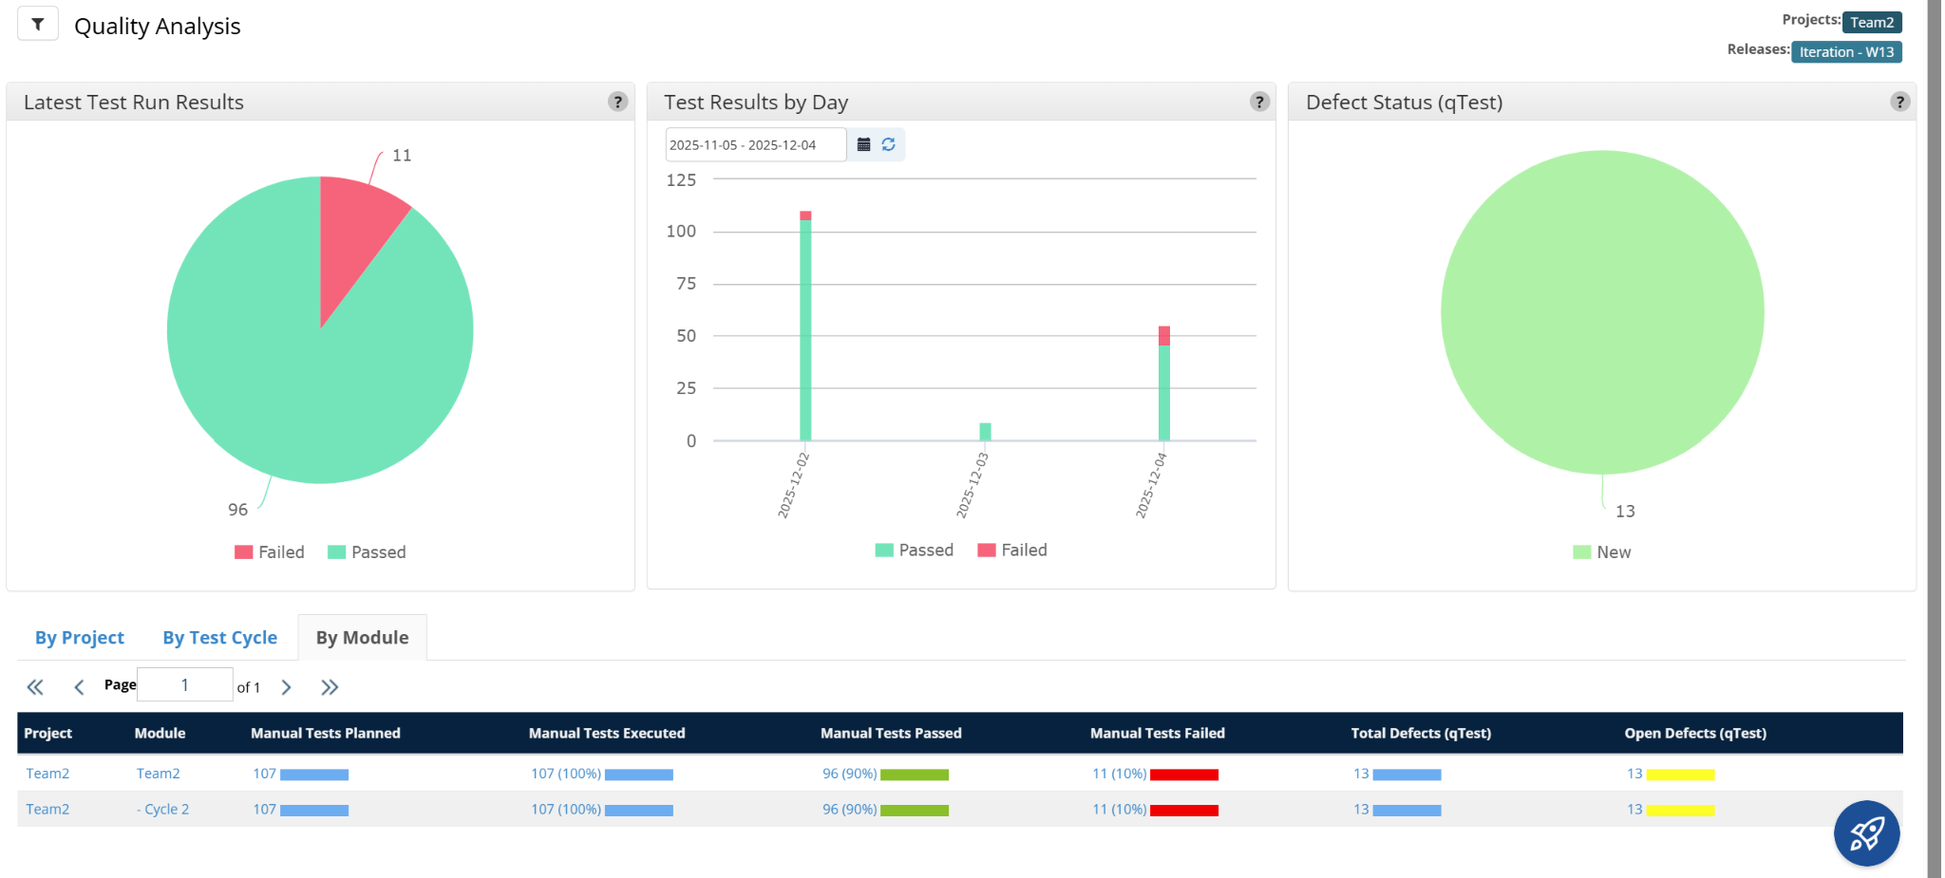

This analysis displays the quality status across different functional modules of the application.
- Identifies modules with higher failure rates or instability.
- Highlights modules that require more testing focus or redesign.
- Helps stakeholders understand which areas are high-risk versus stable.

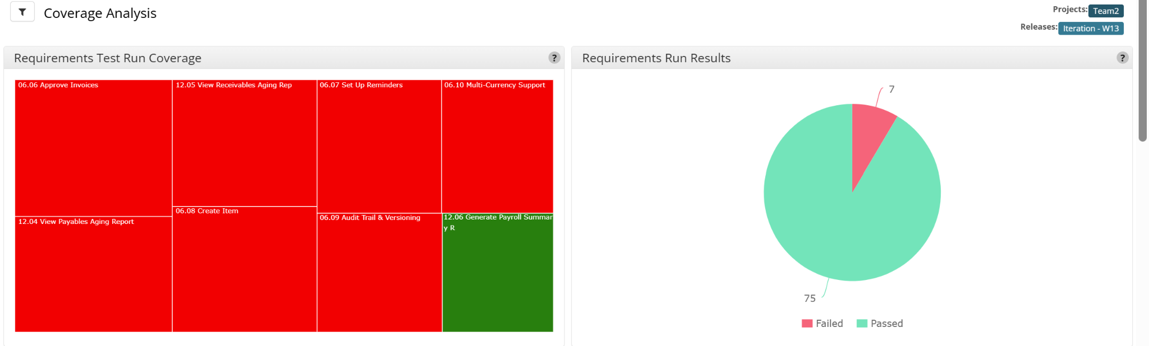

- Shows coverage of each test design document, its test cases, and related test run requirements.
- Ensures all functional requirements are included and tested.
- Indicates completeness of the testing effort and highlights any untested requirements.
- Presents execution results of requirements based on their linked test cases.
- Shows which requirements passed, failed, or were blocked.

5. Types of testing performed (Nimisha George)

1. Functional Testing:
Functional Testing concentrated on validating the core business processes across all three modules. This included:
- Creating, editing, approving, and deleting invoices
- Applying invoice reminders and validating reminder behavior
- Processing payments and updating outstanding balances
- Verifying Accounts Receivable totals, aging summaries, and customer-level balances
- Validating accuracy and completeness of Accounting Reports including Aged Receivables, Profit & Loss, and Balance Sheet
Each workflow was tested end-to-end to ensure data consistency, correct status transitions, and accurate financial calculations. The objective was to confirm that all functions performed according to business requirements without errors.

2. Regression Testing:
Regression testing was performed after each defect fix and during subsequent test cycles to verify that updates in one module did not negatively affect others. Since Invoicing, AR, and Reports are tightly integrated, regression testing ensured stability in:
- Invoice-to-Receivable updates
- Receivable-to-Reports data flows
- Recalculated totals after payments, write-offs, or adjustments
This helped confirm that previous functionalities continued to work as expected.

3. GUI / User Interface Testing
UI testing validated:
- Page layouts, table displays, filter behavior, dropdown controls
- Chart displays and formatting in accounting reports
- Visibility and alignment of labels, buttons, and tooltips
- Consistent behavior across navigation paths
This ensured that the visual interface was intuitive, accurate, and free of UI anomalies.

4. Positive and Negative Testing
Multiple positive and negative scenarios were executed such as:
- Entering valid invoice details (positive)
- Missing mandatory data such as due date or customer email (negative)
- Attempting to generate reports with empty or invalid date ranges (negative)
- Creating invoices with invalid amounts or tax combinations (negative)
This ensured that the system enforced validations correctly and displayed appropriate error messages.

6. Test Environment & Tools (Sreenitha Rayapuraju)
- Server:
  - Type: Virtual Private Server (VPS)
  - Operating System: Linux CentOS 7.5
  - Configuration: 8 vCPUs, 16GB RAM, 200GB SSD Storage
  - Location: Datacenter XYZ
- Database:
  - Type: MySQL 8.0
  - Configuration: 16GB RAM, 500GB Storage
  - Location: Same server as the application
- Application URL: https://www.xero.com
  - Environment: Production
  - Access Credentials: Provided to testing team
- Testing Tools:
  - Test Management Tool: qTest (Vendor Tricentis)
  - Defect Management Tool: JIRA
  - Documentation Archive: GitHub

7. Lessons Learnt (Sharvani Kadarla)

Throughout the testing lifecycle, our team gained several valuable insights that improved both our technical competencies and our overall collaborative efficiency:

1. Importance of Clear Requirement Understanding

We discovered that unclear or incomplete requirements directly affect test case preparation and test execution. Conducting early clarification meetings helped reduce rework, ensured aligned expectations, and improved the accuracy of our test coverage.

2. Value of Well-Structured Test Cases

Creating detailed, reusable, and well-organized test cases proved essential for maintaining consistency across the team. Properly documented test steps reduced confusion, streamlined execution, and allowed defects to be reproduced quickly and accurately.

3. Early Test Planning Helps Prevent Delays

We learned that preparing a comprehensive test plan early in the project helped avoid bottlenecks later. Well-defined scope, schedules, responsibilities, and risk assessments contributed to smoother execution and timely delivery of testing activities.

4. Effective Defect Communication

Clearly describing defects with accurate severity, priority, screenshots, and step-by-step reproduction details significantly improved the resolution process. In contrast, incomplete defect logs led to unnecessary delays and repeated discussions.

5. Collaboration Enhances Productivity

Frequent and open communication within the team—through daily stand-ups, status updates, and quick discussions—helped us resolve issues faster and ensured alignment across all testing efforts. Collaboration played a key role in maintaining momentum.

6. Necessity of Requirement Traceability

Maintaining traceability between requirements, test cases, and defects helped ensure complete coverage and prevented duplication of effort. It also simplified reporting on test coverage during review and closure phases.

7. Better Time Management is Essential

Balancing tasks such as test design, execution, retesting, and reporting highlighted the need for proper prioritization. Approaches like risk-based testing and grouping related scenarios helped us manage time effectively and meet deadlines.

8. Recommendations (Nimisha George)
Based on the testing activities performed across the Invoicing, Accounts Receivable, and Accounting Reports modules, the following recommendations are proposed to improve the efficiency of future testing cycles and overall system usability:
- Streamline Access and Permission Requests
Establishing clear communication channels and a standardized documentation process for requesting user permissions would reduce delays in gaining access to required modules. This will help avoid dependency on administrators for basic role updates during testing.
- Provide Controlled Admin Access to Test Leads
Allowing the test lead to limited administrative control—specifically for managing access rights within the test environment—would eliminate repeated requests to system administrators and expedite onboarding of new testers.
- Include an Access-Rights Checklist in Test Preparation
Maintaining a predefined checklist of required permissions for each module (Invoicing, AR, Reporting) would help testers verify their access before execution begins, preventing interruptions mid-cycle.
- Introduce Training or Sandboxed Environment for Permission Handling
Encouraging testers to practice creating and managing access rights in a safe, sandboxed environment would help them become familiar with Xero’s permission model. This improves confidence in entitlement testing and reduces dependency on others for setup.

9. Best Practices (Koushika Chappidi)
Throughout the testing cycles, our team adopted a structured and disciplined approach to ensure accuracy, consistency, and maintainability across all modules. The following best practices were applied:

1. Prepare Clear and Complete Test Documentation: Before execution, the team created detailed test cases with defined preconditions, test steps, expected results, and validation rules. This ensured uniform understanding across testers and minimized ambiguity during execution.

2. Maintain Traceability Between Requirements and Test Cases: All test cases were mapped back to their respective business requirements, enabling complete coverage, reducing duplication, and supporting accurate tracking of testing progress.

3. Leverage qTest for Organized Test Management: qTest was used to plan, execute, record, and track test outcomes. Maintaining logs within qTest improved collaboration, allowed better monitoring of defect resolution, and ensured streamlined reporting across cycles.

4. Follow a Consistent Execution Flow: Testers executed cases systematically, capturing screenshots, output variations, and system behaviors. Defects were logged immediately with proper severity, reproduction steps, and supporting evidence to reduce developer turnaround time.

5. Retest and Re-run Regression Cycles: After each fix, retesting ensured defect resolution, and regression cycles helped verify that changes did not impact dependent modules such as Accounts Receivable and Reports.

6. Collaborate Actively for Clarity and Efficiency: Regular communication during stand-ups and review meetings helped align interpretations, refine test scenarios, and reduce misunderstandings that would otherwise delay the testing process.

7. Validate Cross-Cutting Concerns Thoroughly: Entitlements, data flows (DF-In/DF-Out), system-driven recalculations, and status updates were validated across multiple scenarios to ensure end-to-end consistency within the application.
These best practices strengthened the overall quality of testing, ensured reliable coverage, and contributed to delivering a stable and well-validated system for stakeholder review.

10. Exit Criteria (Kevin Rodrigues)
Testing activities will be considered complete when all the following exit criteria are met:
- All planned test cases are executed
100% of test cases defined in the Test Plan/Test Suite have been executed across all applicable functional areas.
- Defect Threshold Requirements
All Critical and High severity defects are fixed, retested, and closed.
No Critical or High defects remain open at the time of closure.
- Test Artifacts Completed
All test deliverables are completed, reviewed, and approved.
The following images display the execution of all planned test cases that were conducted as part of test cycles 1 and 2.

CYCLE 1 TEST EXECUTION LOG:
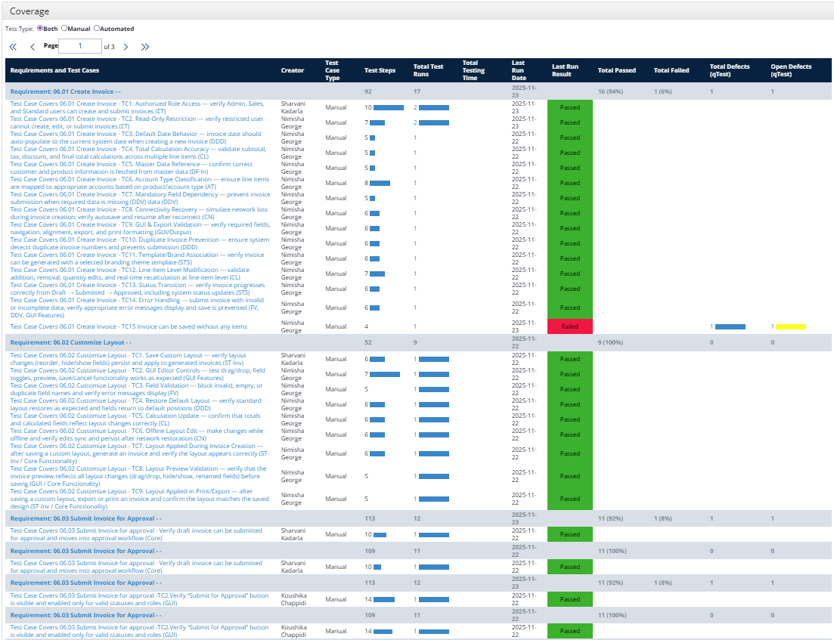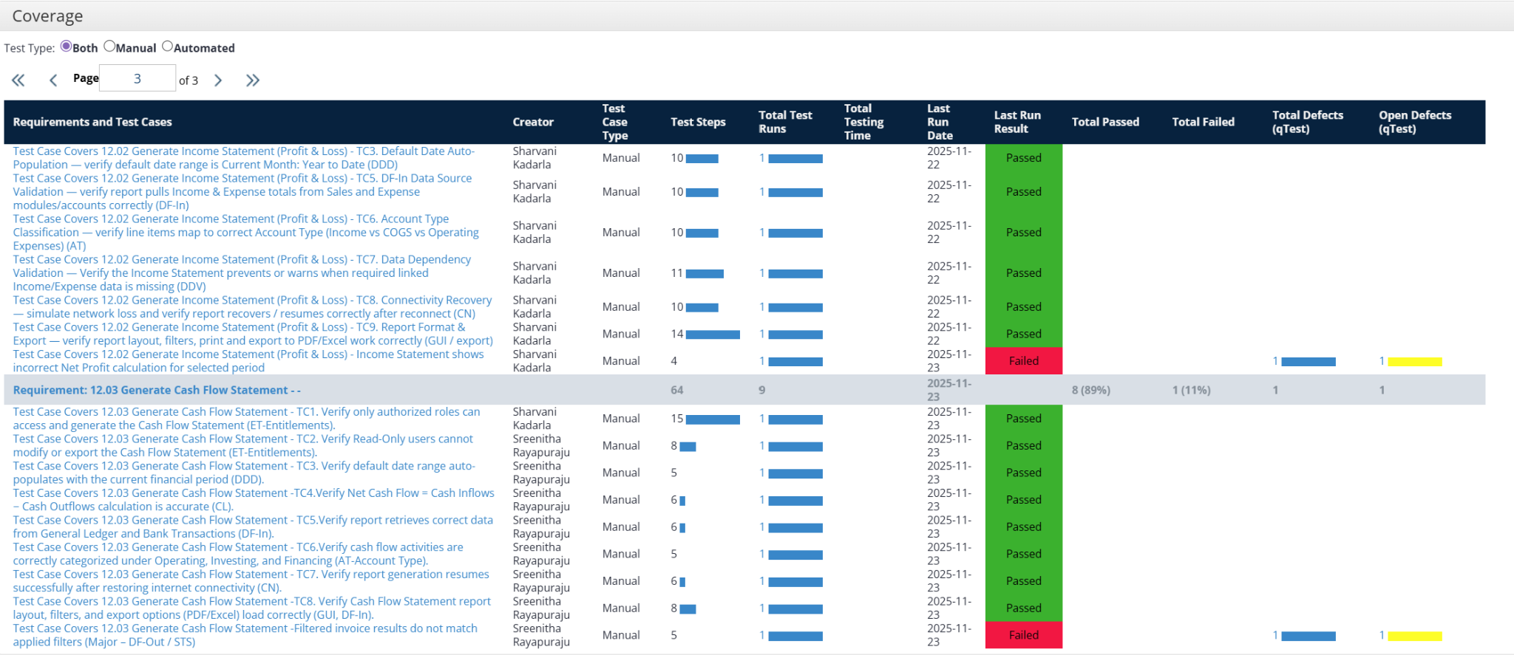
CYCLE 2 TEST EXECUTION LOG:
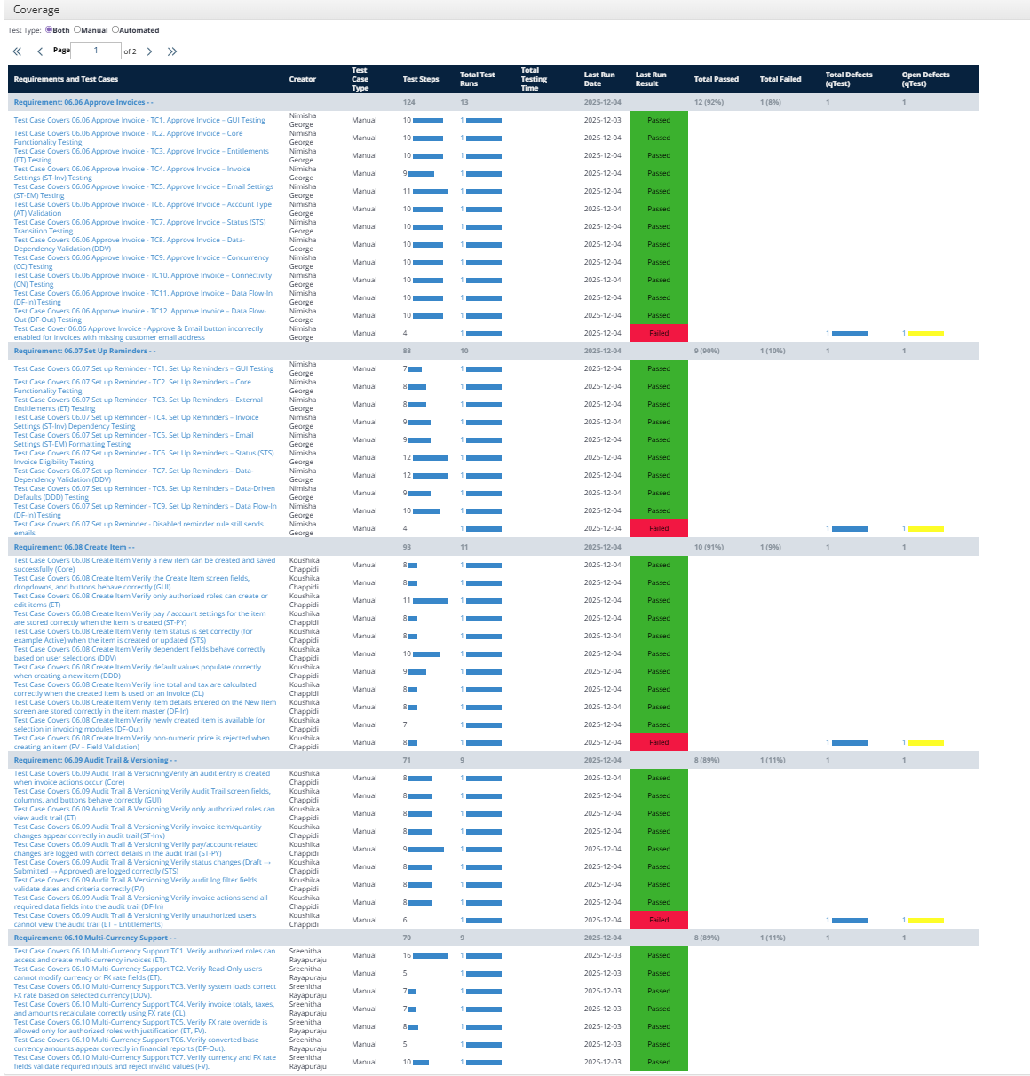
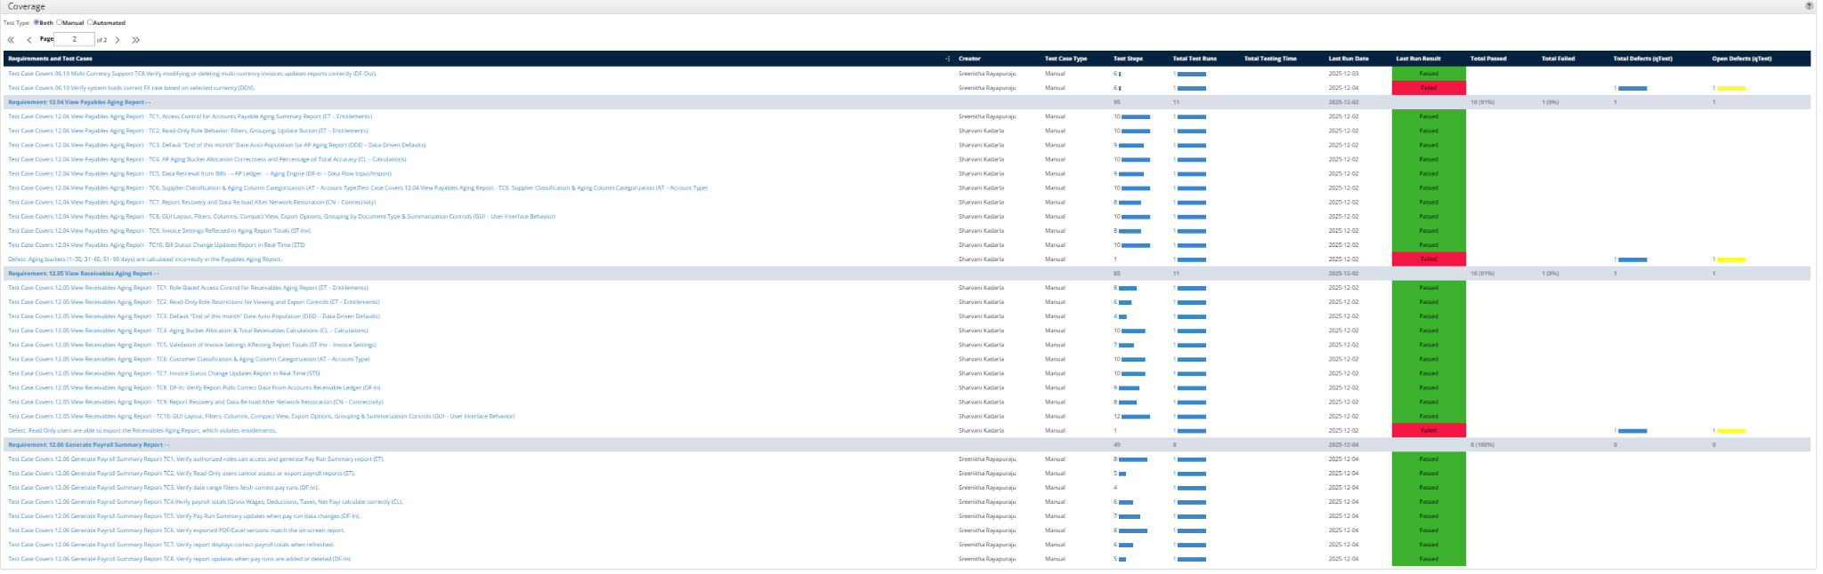

11. Conclusion/Sign Off (Kevin Rodrigues)

The testing activities for the Xero application specifically Invoice Module, Accounting Reports module and Accounts Receivable module have been successfully completed in accordance with the defined scope, objectives, and exit criteria. All planned test cases were executed, and the overall quality of the application has been validated across core functionality, field validation, entitlements, data flow, connectivity behavior, and UI/UX components. The application meets the required functional and non-functional expectations, and the results demonstrate that the system is stable, reliable, and ready for release to production.

12. Definitions, Acronyms, and Abbreviations (Sharvani Kadarla)

- qTest: A test management tool used by testing teams to streamline test planning, execution, and reporting processes. It provides functionalities such as test case management, test execution tracking, defect management, and real-time reporting, facilitating efficient collaboration and ensuring comprehensive test coverage throughout the software development lifecycle.
- JIRA: A project management and issue tracking software developed by Atlassian. It allows teams to plan, track, and manage projects using customizable workflows, agile boards, and real-time reporting. JIRA enables teams to create, prioritize, assign, and track tasks, issues, and bugs throughout the development lifecycle.
- UAT (User Acceptance Testing): The phase where end-users validate the application to ensure it meets their requirements and expectations before deployment. UAT helps identify discrepancies or areas for improvement impacting functionality or user experience.
URL (Uniform Resource Locator): A web address that specifies the location of a resource on the internet.
- Defect: Any deviation from the expected behavior of the application identified during testing.
- Severity: Indicates the impact of a defect on the system or application functionality (e.g., Critical, Major, Minor).
- Priority: Determines the order in which defects should be resolved based on business importance or urgency (e.g., High, Medium, Low).
- Action Plan: A detailed plan outlining the steps to address and resolve any open defects or issues identified during testing, ensuring timely resolution and quality assurance.
- Test Environment: The setup of software, hardware, and network configurations used for testing purposes. This environment should accurately simulate real-world usage scenarios to ensure comprehensive testing coverage.
- Test Log: A record of executed test cases, including results, timestamps, and any deviations or incidents observed during execution.
- Test Incident Report: Documentation of any unexpected events, defects, or anomalies observed during testing, requiring further investigation or resolution.
- Test Case: A documented set of conditions, inputs, and expected results designed to verify a particular feature or functionality of the application.
- Test Plan: A document outlining the scope, approach, resources, schedule, and responsibilities for testing activities, as well as risk assessment and mitigation strategies.
- Test Scenario: A high-level description of a functionality or feature to be tested, often covering multiple test cases.
- Regression Testing: Testing performed to ensure that new changes or enhancements do not adversely affect existing functionality.
- Functional Testing: Testing that verifies the application behaves according to specified functional requirements.
- Performance Testing: Testing conducted to evaluate the responsiveness, stability, and scalability of the application under load conditions.
- Traceability Matrix: A document mapping requirements to test cases, ensuring all requirements are tested and helping identify any gaps in coverage.
- Automation Tool (if applicable): Tools such as Selenium, UFT, or similar, used to automate test execution for efficiency, repeatability, and reliability.
- SDLC (Software Development Life Cycle): The overall process of planning, creating, testing, and deploying software applications.
- CMMI (Capability Maturity Model Integration): A process improvement framework that ensures quality and efficiency in software development and testing processes.
- Stakeholders: Individuals or groups who have an interest or investment in the software project, including clients, management, and end-users.
- Release/Build: A specific version of the software that has been compiled and packaged for testing or deployment purposes.

